Angular Services are pieces of code or logic used to perform a specific task. A service can contain a value, function, or combination of both. Angular services are injected into the application using the dependency injection mechanism.

**Need of service :**

Whenever you need to reuse the same data and logic across multiple components of your application, then you need to go for angular service. That means whenever you see the same logic or data-access code duplicated across multiple components, then you need to think about refactoring the same logic or data access code into a service.

services is a mechanism used to share the functionality between the components.

Steps :

1. **Creating Angular Service :** The angular service is composed of three things.
   1. To create service type in to terminal :
      1. **ng generate service  <servicename >**

**e.g.** ng generate service Student

* 1. an **export**class
  2. decorate that class with **@Injectable** decorator
  3. import the Injectable decorator from the angular core library.
  4. It will create two files within the app folder.



1. **Modifying student.service.ts file :**

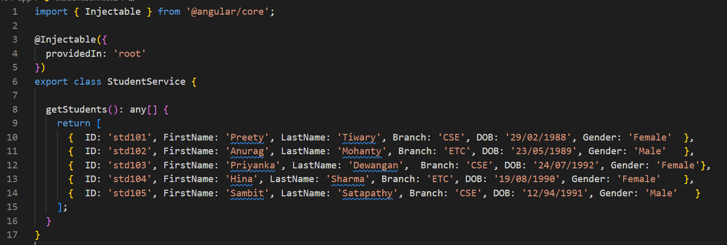

The **@Injectable()** decorator in angular is used to inject other dependencies into the service.

1. **Using the Service in Angular :** It is a three-step process.
   1. Import the service
   2. Register the service : register the Service in the component by declaring it in the providers array.
   3. Use the service : Inject StudentService using the constructor.

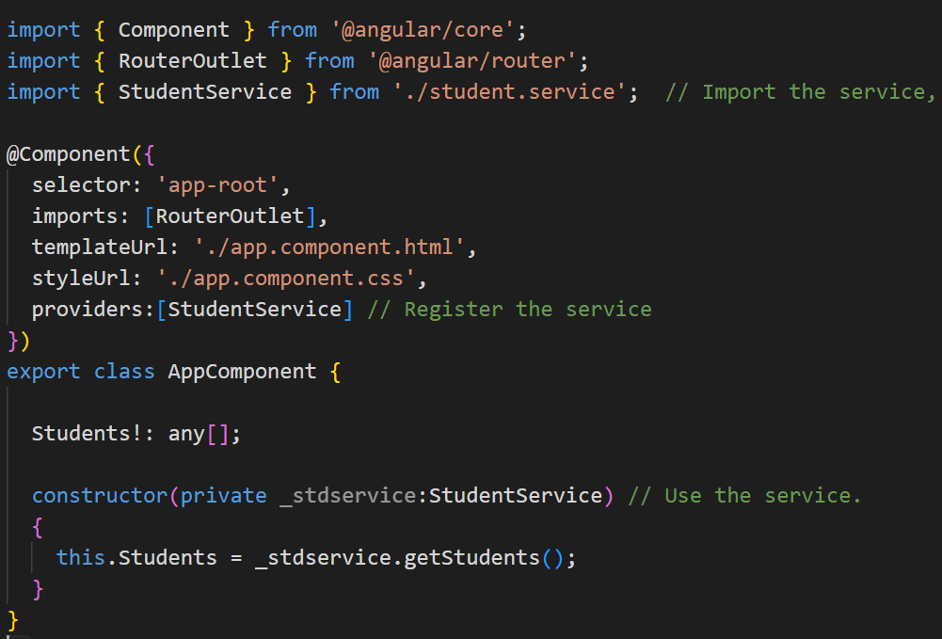

1. **Modifying app.component.html file :**

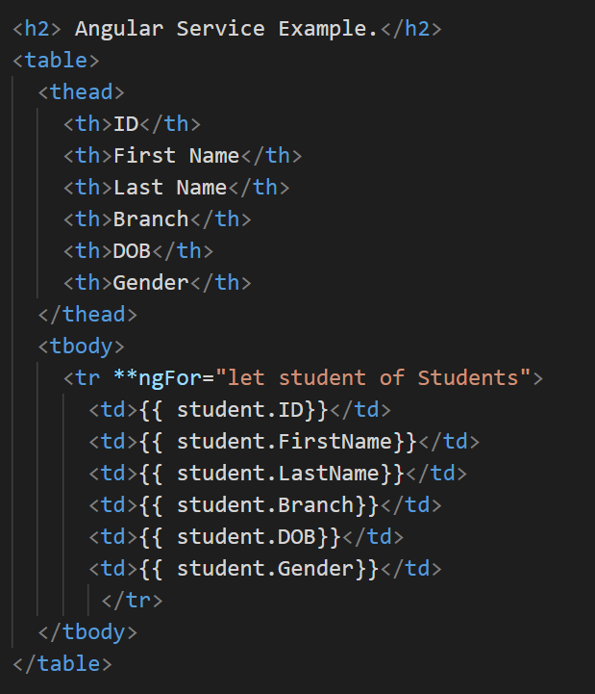

**Using ngOnInit()**

Modify the app.component.ts file to use ngOnInit life cycle hook to call the getStudents method of Student Service.

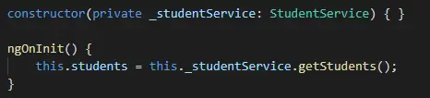

ngOnInit is the right place to call a service method to fetch data from a remote server.

Tasks that are time consuming should use ngOnInit instead of the constructor.